HR Dashboard

Building Data Source 1

Collect Data 3

Connect Data 5

Check Data Types 6

Explore the Data 6

Building Charts 6

Analyse Requirements and Choose Charts 7

Initial Format of Sheet 7

Create Calculated Fields 7

Creating BAN Hired 7

Build Charts and Format Charts 8

Create Line Graph for Hired by Year 8

Create Line Graph for Terminated by Year 8

Create a Bar Graph for Department Breakdown 9

Create a Bar Chart to Compare Total Employees Between HQ and Branches 9

Create a Map to Show Distribution of Employees by City and State 9

Create a Pie Chart to Show Gender Ratio 10

Create a Heatmap to Show the Distribution of Age Groups and Education Levels 10

Create Bar Chart to Show the Total Number of Employees in Each Age Group 11

Create Bar Chart to Show the Total Number of Employees in Each Education Level 11

Create a Heatmap to Show the Distribution of Performance ratings and Education Levels 11

Create a Barbell Chart to Compare Salaries Across Education Levels for Both Genders 11

Create a Scatterplot to Show How Age Correlates with Salary in Each Department 12

Building Dashboard 12

Plan the Dashboard - Dashboard Mock-up 12

Plan the Dashboard - Container Mock-up 13

Create Container structure 13

Put all Together 13

Fixing Colours 13

Fix Texts 13

Fix Spacing 13

Fix Tooltips 13

Add Filters and Legends 13

Add Logos and Icons 13

# Building Data Source

As an HR manager, I want a comprehensive dashboard to analyse human resources data, providing both summary views for high-level insights and detailed employee records for in-depth analysis

**Summary View**

The summary view should be divided into three main sections: Overview, Demographics, and Income Analysis

**Overview**

The Overview section should provide a snapshot of the overall HR metrics, including:

* Display the total number of hired employees, active employees, and terminated employees.
* Visualize the total number of hired and terminated employees over the years.
* Present a breakdown of total employees by department and job titles.
* Compare total employees between headquarters (HQ) and branches (New York is the HQ)
* Show the distribution of employees by city and state.

**Demographics**

The Demographics section should offer insights into the composition of the workforce, including:

* Present the gender ratio in the company.
* Visualize the distribution of employees across age groups and education levels.
* Show the total number of employees within each age group.
* Show the total number of employees within each education level.
* Present the correlation between employees' educational backgrounds and their performance ratings.

**Income**

* The income analysis section should focus on salary-related metrics, including:
* Compare salaries across different education levels for both genders to identify any discrepancies or patterns.
* Present how the age correlate with the salary for employees in each department.

**Employee Records View**

* Provide a comprehensive list of all employees with necessary information such as name, department, position, gender, age, education, and salary.
* Users should be able to filter the list based on any of the available columns.

## Collect Data

The data used in this HR Dashboard project is generated using a combination of ChatGPT prompts and the Python Faker library. This dataset simulates a set of employee information typically found in HR systems, including demographics, job details, salary, performance evaluations, and attrition data. The generated data is designed to mimic real-world HR data, providing a rich dataset for analysis and visualization in Tableau.

**Chat-GPT Prompts**

Generate python script to generate a realistic dataset of 8950 records for human resources. The dataset should include the following attributes:

1. Employee ID: A unique identifier.
2. First Name: Randomly generated.
3. Last Name: Randomly generated.
4. Gender: Randomly chosen with a 46% probability for ‘Female’ and a 54% probability for ‘Male’.
5. State and City: Randomly assigned from a predefined list of states and their cities.
6. 6.Hire Date: Randomly generated with custom probabilities for each year from 2015 to 2024.
7. 7.Department: Randomly chosen from a list of departments with specified probabilities.
8. Job Title: Randomly selected based on the department, with specific probabilities for each job title within the department.
9. Education Level: Determined based on the job title, chosen from a predefined mapping of job titles to education levels.
10. Performance Rating: Randomly selected from ‘Excellent’, ‘Good’, ‘Satisfactory’, ‘Needs Improvement’ with specified probabilities.
11. Overtime: Randomly chosen with a 30% probability for ‘Yes’ and a 70% probability for ‘No’.
12. Salary: Generated based on the department and job title, within specific ranges.
13. Birth Date: Generated based on age group distribution and job title requirements, ensuring consistency with the hire date.
14. Termination Date: Assigned to a subset of employees (11.2% of the total) with specific probabilities for each year from 2015 to 2024, ensuring the termination date is at least 6 months after the hire date.
15. Adjusted Salary: Calculated based on gender, education level, and age, applying specific multipliers and increments.
16. Be sure to structure the code cleanly, using functions where appropriate, and include comments to explain each step of the process.

This generated 8950 individual employees with the following metadata:

**employee_id** – A unique id “00-XXXXXXXX”, where XXXXXXXX= 10000000:99999999  
**first_name** – First name  
**last_name** – Last name  
**gender** – “Male” or “Female”  
**state** –   
'New York'  
'Virginia'  
'Florida'  
'Illinois': ,  
'Pennsylvania'  
'Ohio'  
'North Carolina'  
'Michigan'  
**city** – Based on state  
['New York City', 'Buffalo', 'Rochester']  
['Virginia Beach', 'Norfolk', 'Richmond']  
['Miami', 'Orlando', 'Tampa']  
['Chicago', 'Aurora', 'Naperville']  
['Philadelphia', 'Pittsburgh', 'Allentown']  
['Columbus', 'Cleveland', 'Cincinnati']  
['Charlotte', 'Raleigh', 'Greensboro']   
['Detroit', 'Grand Rapids', 'Warren']  
**hiredate** – Date of hire  
**department** - 'HR', 'IT', 'Sales', 'Marketing', 'Finance', 'Operations', 'Customer Service'  
**job_title** – Depending on department  
'HR': ['HR Manager', 'HR Coordinator', 'Recruiter', 'HR Assistant'],  
'IT': ['IT Manager', 'Software Developer', 'System Administrator', 'IT Support Specialist'],  
'Sales': ['Sales Manager', 'Sales Consultant', 'Sales Specialist', 'Sales Representative'],  
'Marketing': ['Marketing Manager', 'SEO Specialist', 'Content Creator', 'Marketing Coordinator'],  
'Finance': ['Finance Manager', 'Accountant', 'Financial Analyst', 'Accounts Payable Specialist'],  
'Operations': ['Operations Manager', 'Operations Analyst', 'Logistics Coordinator', 'Inventory Specialist'],  
'Customer Service': ['Customer Service Manager', 'Customer Service Representative', 'Support Specialist', 'Help Desk Technician'

**education_level -** 'High School', "Bachelor", "Master", 'PhD'  
**salary -** Salary based on department and title  
**performance_rating - '**Excellent', 'Good', 'Satisfactory', 'Needs Improvement**'**  
**overtime** - ‘Yes’ or ‘No’  
**birthdate –** Birthdate  
**termdate** - Termination Date, “Blank” if still works at company

## Connect Data

On tableau we just select the csv file from the file explorer. As it is only 1 file, we don’t need to build a data model

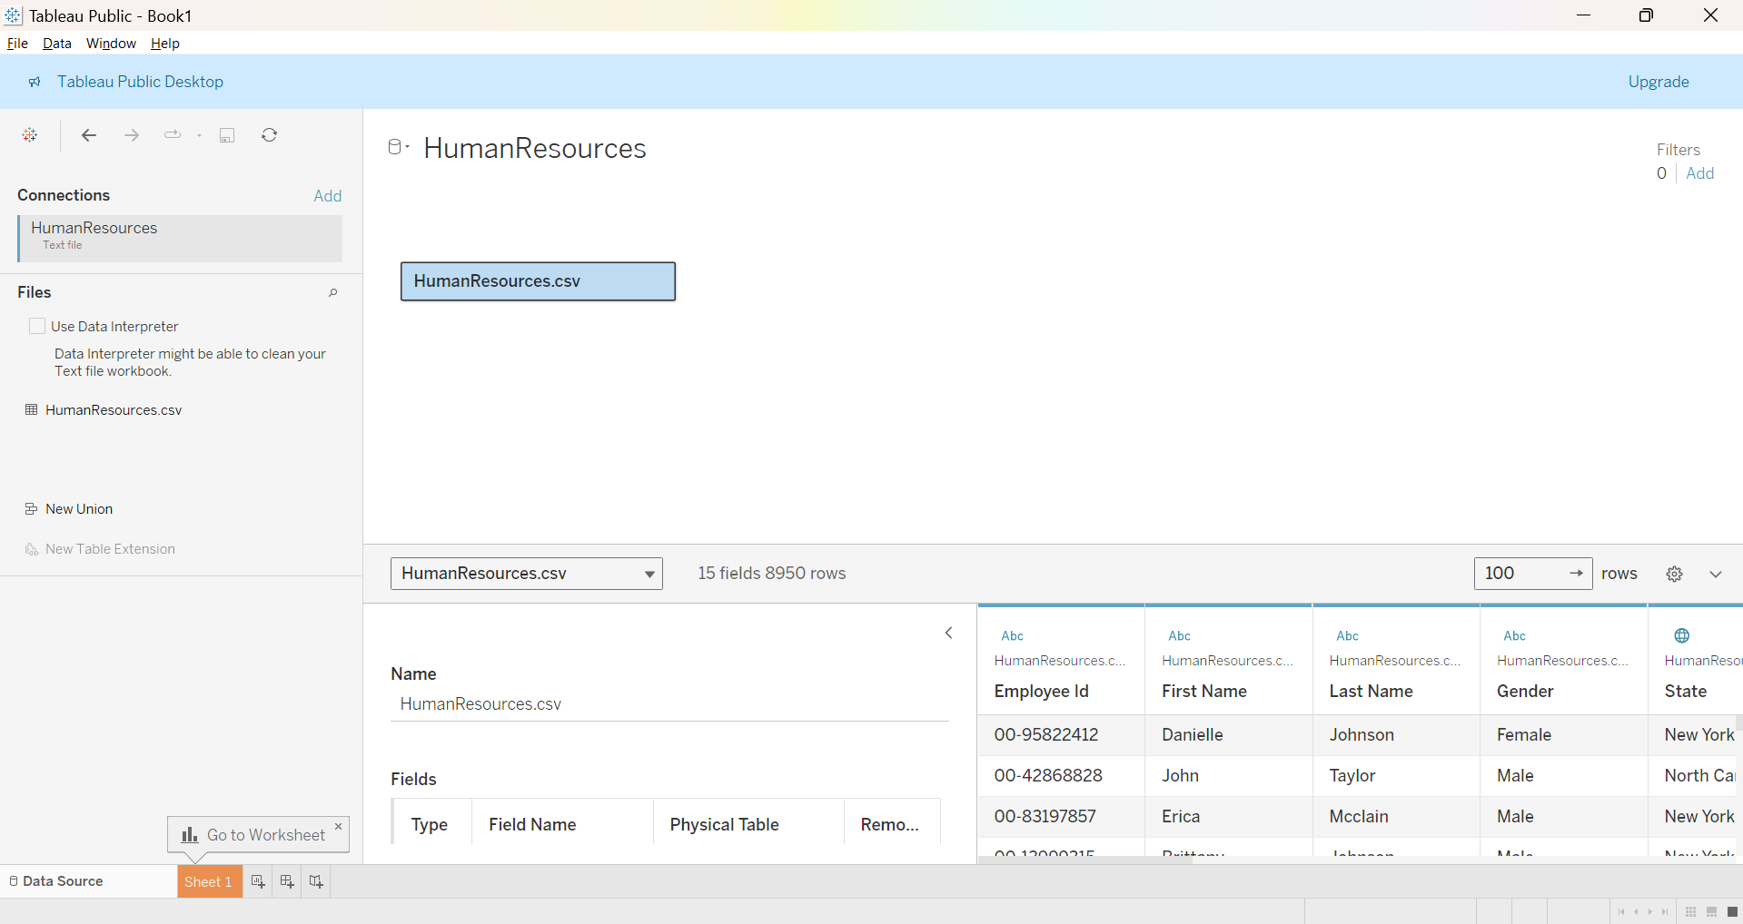Check Data Quality

We want Tableau to use the first row as column headers, so we right click the table and check the setting is enabled:

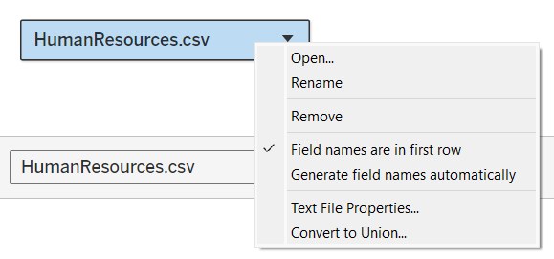

Under “Text File Properties...” we want the following:

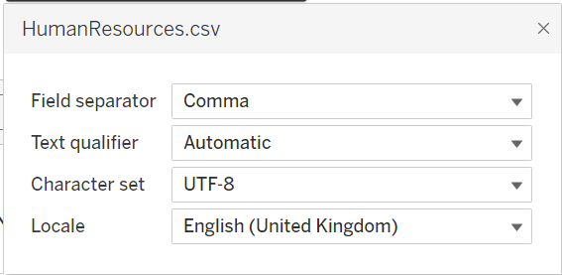

## Check Data Types

Below are what each column and corelating data type should be

employee_id - String  
first_name - String  
last_name - String  
gender - string  
state – Geographic Role - State/Province  
city - Geographic Role - City  
hiredate - Date  
department - String  
job_title - String  
education_level - String  
salary – Number (whole)  
performance_rating - String  
overtime - String  
birthdate - Date  
termdate - Date

## Explore the Data

Because ‘department’ has bearing on ‘job_title’ we will create a hierarchy by dragging the ‘job_title’ onto ‘department’

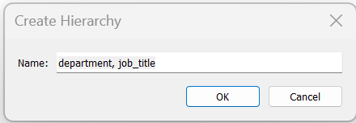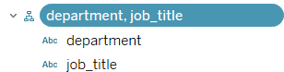

# Building Charts

From the brief:

As an HR manager, I want a comprehensive dashboard to analyse human resources data, providing both summary views for high-level insights and detailed employee records for in-depth analysis

## Analyse Requirements and Choose Charts

## Initial Format of Sheet

Format the sheet so it can be used for every sheet and don’t have to re-format every time.

1. Marks -> Colours -> More Colours -> “Add Custom Colours”

#03c4a1 - Turquoise  
#c52a87 – Pink  
#777777 – Dark Grey  
#f5f5f5 – Light Grey

1. Format -> Workbook:  
   Font: Trebuchet MS and change the colour to #777777 – Dark Grey
2. Format -> Shading:  
   Worksheet Colour: First dark grey under black
3. Change the view to ‘Entire View’
4. Remove titles: Right click-> ”Hide Title”

## Create Calculated Fields

Part of the brief described calculating the total number of hired employees, active employees, and terminated employees. We will do this with calculated fields.

Total Hired = Count([employee_id])  
Total Terminated = Count(IF NOT ISNULL([termdate]) Then [employee_id] END)  
Total Active = Count(IF ISNULL([termdate]) Then [employee_id] END)

#### Creating BAN Hired

Drag “Total Hired” to Text and select the following:  
Allignment: Middle, Font size: 18 and Font Colour: #f5f5f5 – Light Grey  
Select Text -> Alignment -> Horizontal: Middle  
 -> Vertical: Middle

Rename the sheet BAN Hired. Duplicate the tab twice and do the same for “Total Active” and “Total Terminated”

## Build Charts and Format Charts

#### Create Line Graph for Hired by Year

The first graph we need is a line graph to tackle:

“Visualize the total number of hired and terminated employees over the years.”

1. Create a new sheet called “Hired By Year”
2. Drag ‘hiredate’ to Columns and ‘Total Hired’ to Rows
3. Right click y-axis and ‘edit axis’ then deselect “Include 0”
4. Change the Colour of the line to #03c4a1 – Turquoise
5. Dupe the graph by holding “CTRL” + dragging the “Total Hired” to the right and letting go
6. Change the bottom graph to an ‘area’ graph
7. Right click the right of the two measures in the Rows and select “Dual Axis”
8. Right click the right y-axis and select “Synchronise axis”
9. Remove axis and the year groupings and deselecting the “Show Header” option
10. Right click the background of the visual and select format
    1. Select the lines icon in the top left
    2. Change the “Grid Lines” to none
    3. Select the Borders icon left of the line's icon -> Sheet
    4. Change Row and Column Divider Pane to “None”
11. Select the area chart and change the opacity of the colour to 15%
12. Select the line chart and make the line smaller by changing it in the size tile

#### Create Line Graph for Terminated by Year

1. Dupe the last sheet then just replace all the fields as follows: (Dragging the field directly on top of the other field will replace it)  
   hiredate -> termdate  
   Total Hired -> Total terminated
2. Right click “Null” in the x-axis and select “Hide”
3. Hide the axes as before
4. Select “All” above the two charts and change the colour to #c52a87 – Pink
5. To remove the white dotted line at the bottom, right click and select format
   1. Select the line icon
   2. Change “Zero Line” to “None”

#### Create a Bar Graph for Department Breakdown

1. Dupe the previous sheet, replace the fields with “Total Hired” - Columns and “department” - Rows
2. Change the chart type to Bar
3. Chage the colour to #03c4a1 – Turquoise
4. Order the bars descending by pressing the button text to “Total Hired” on the x-axis
5. Double click in the white space next to “department” in the rows field and type “Index()”
6. Right click the new measure and change it to discrete, then switch the order of the fields
7. Hide the x-axis and remove grid lines

#### Create a Bar Chart to Compare Total Employees Between HQ and Branches

New York is the HQ all others are branches.

1. Create a calculated field called Location

CASE [state]   
 WHEN 'New York' THEN 'HQ'  
 ELSE 'Branch'  
END

1. Drag “Location” to Columns and “Total Hired” to rows
2. Change the colour of the bars. Branch to #777777 – Dark Grey and HQ to #03c4a1 – Turquoise
3. Right click the Location field and select “Sort...” -> Select Manual and put HQ before Branch.
4. Remove Title and change Axis Rulers and Axis Ticks to “None”
5. Hide the legend card by clicking the drop down and selecting hide

#### Create a Map to Show Distribution of Employees by City and State

1. Dupe the previous chart
2. Drag Longitude to Columns, Latitude to rows and state to Detail
3. There are 8 unknowns, so select “Map” in the ribbon then select “Edit Locations”
4. Change the country to USA and press OK
5. Change the chart type to “Map”
6. Select “Map” from the ribbon and select “Background Layers”
   1. Change the style to “Dark”
   2. Deselect all options from the “Background Map Layers”
7. Hold “CTRL” and move the state to Label
8. Change the colour to #03c4a1 – Turquoise and change the Opacity to 30%. Then change the border to the bottom grey within the black column
9. Drag “City” to “Add a Marks Layer”
   1. “state” to detail
   2. “Total Hired” to size and increase the size to just between ¼ and ½
   3. “Location” to Colour and add #03c4a1 – Turquoise as the border colour, then change opacity to 30%
10. Remove both the legend cards

#### Create a Pie Chart to Show Gender Ratio

1. Dupe the Locations sheet, remove all the fields and a name the sheet “Gender”
2. Change the graph type to Pie
3. Double click in the columns area and type “AVG(0)” this sets a place holder visual
4. Dupe the field that was just created, we will have an inner pie and outer pie
5. Right click the right field and select “Dual Axis”, then right click either x-axis and synchronise them
6. Hide both axis
7. Select “All” in the Marks and change the size to just between ¼ and ½
8. Select the Second of the 2 Marks
   1. Change the colour to something dark
   2. Change the size to a ¼
9. Drag “Total Hired” to label and select the other chart in the Marks
10. Drag “gender” to Colour and change the colour of “Male” to #03af8f – darker turquoise and change “Female” to #44ffdd – lighter turquoise
11. CTRL drag “gender” to Label and then drag “Total Hired” to Label
12. Right click the new “Total Hired” field and select “Quick Table Calculation” -> “Percentage of Total”
13. Right click “Total Hired” field again and select “Format” change Percentage-> “Numbers” to 1dp
14. Drag the Total Hired field down to the calculated fields and name it % Total Hired
15. Hide the legend

#### Create a Heatmap to Show the Distribution of Age Groups and Education Levels

1. Dupe the Gender page, remove all fields and name it “Age vs Education”
2. Create a new calculated field called “Age”  
   DATEDIFF('year', [birthdate], TODAY())
3. When dragging “Age” to rows right click and change it to “Discrete” and a “Dimension”
4. Create another calculated field called “Age Groups”  
   If [Age] < 25 THEN '>25'

ELSEIF [Age] >= 25 AND [Age] < 35 THEN '25-34'

ELSEIF [Age] >= 35 AND [Age] < 45 THEN '35-44'

ELSEIF [Age] >= 45 AND [Age] < 55 THEN '45-54'

ELSEIF [Age] >= 55 THEN '55+'

END

1. Replace “Age” with “Age Groups” in rows and drag “education_level” to columns
2. Change the graph type to Circle
3. Drag “Total Hired” to size
4. Right click on “Age Groups” and select “Sort” -> Manual and sort the groups in age order. Then do the same for “Education”
5. Change the colour to #777777 – Grey and remove the Card

#### Create Bar Chart to Show the Total Number of Employees in Each Age Group

1. Dupe the sheet, remove all except “Age Group” and rename the sheet Age Groups
2. Change the chart type to Bar
3. Hide the y-axis

#### Create Bar Chart to Show the Total Number of Employees in Each Education Level

1. Dupe the previous sheet, rename it “Education Levels” and replace the “Age Group” fields with “Education Level”
2. Right click the field and manually sort into the correct order

#### Create a Heatmap to Show the Distribution of Performance ratings and Education Levels

1. Dupe and rename Education vs Performance and replace the “Total hired” field with the “Performance Rating” field
2. Change the chart type to square
3. Manually sort the “Performance Ratings” to be the right order
4. Drag “% Total Hired” to size
5. Right click the “% Total Hired” select Compute Using -> Performance rating

#### Create a Barbell Chart to Compare Salaries Across Education Levels for Both Genders

1. Duplicate the sheet, rename the sheet “Gender vs Education Level” , remove all fields except “Education Level” move that field to rows
2. Drag “Salary” to columns and change it from sum to average
3. CTRL drag “Salary” to the right to dupe it and within the marks pane change the first graph to a line
4. Drag “Gender” to Path and change the size to max
5. Select the second mark change the graph type to shape and drag “Gender to shape”
6. Follow the instructions here to add custom shapes to tableau
7. Change the shape to “Gender” and use the appropriate shape
8. CNTRL drag “Gender” to colours and change the size to halfway
9. Right click the right “Salary” field and make it a dual axis, then sync axes.
10. Edit the axis to remove 0.
11. CTRL drag the left “Sales” to label and change the font colour to Light Grey #f5f5f5 and set the alignment to automatic
12. Right click the label “Salary” field and select format. Change the “Custom Numbers” to 0dp and set “Display Units” to thousands.
13. Remove axes and cards

#### Create a Scatterplot to Show How Age Correlates with Salary in Each Department

1. Dupe the sheet, name the sheet Age vs Salary and remove all fields
2. Drag “Age” to columns and “Salary” to rows and change both to average
3. Drag “Job Tile” to Detail and remove 0 from the x-axis and y-axis
4. Change the shape to filled diamonds and reduce the opacity to 75%
5. CTRL drag “Job title” to label, reduce the font size to 8
6. Right click the y-axis and select “Add Reference Line”
   1. Change Label to “None”
   2. Change Tooltip to Custom and in the next box select “Value”
   3. Format the line to be the first dashed option, thinnest option and change the colour to Dark grey - #777777
   4. Do the same for the x-axis

# Building Dashboard - Overview

## Plan the Dashboard - Dashboard Mock-up

Here is a rough draft of how the dashboard will be layed out

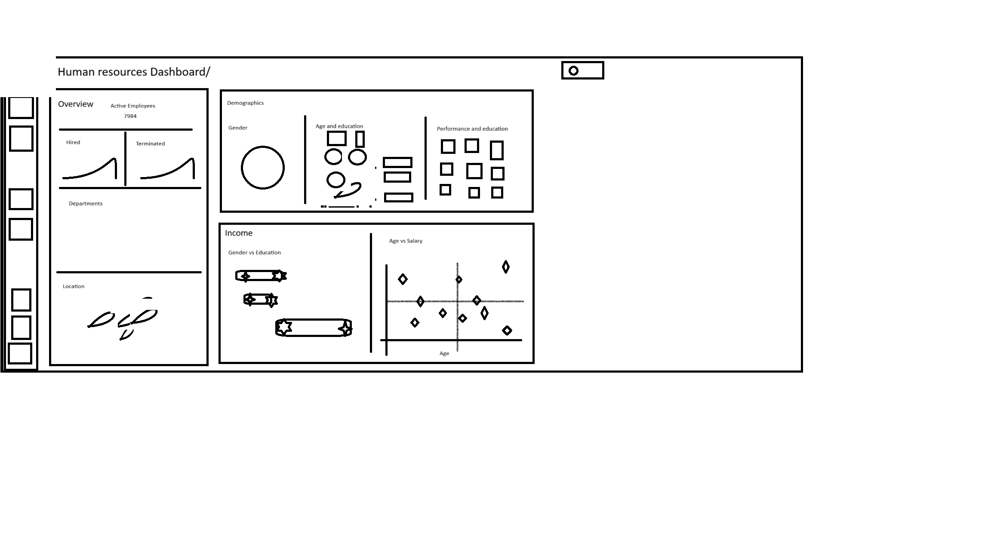

## Plan the Dashboard - Container Mock-up

Using draw.io here is a container mock-up.

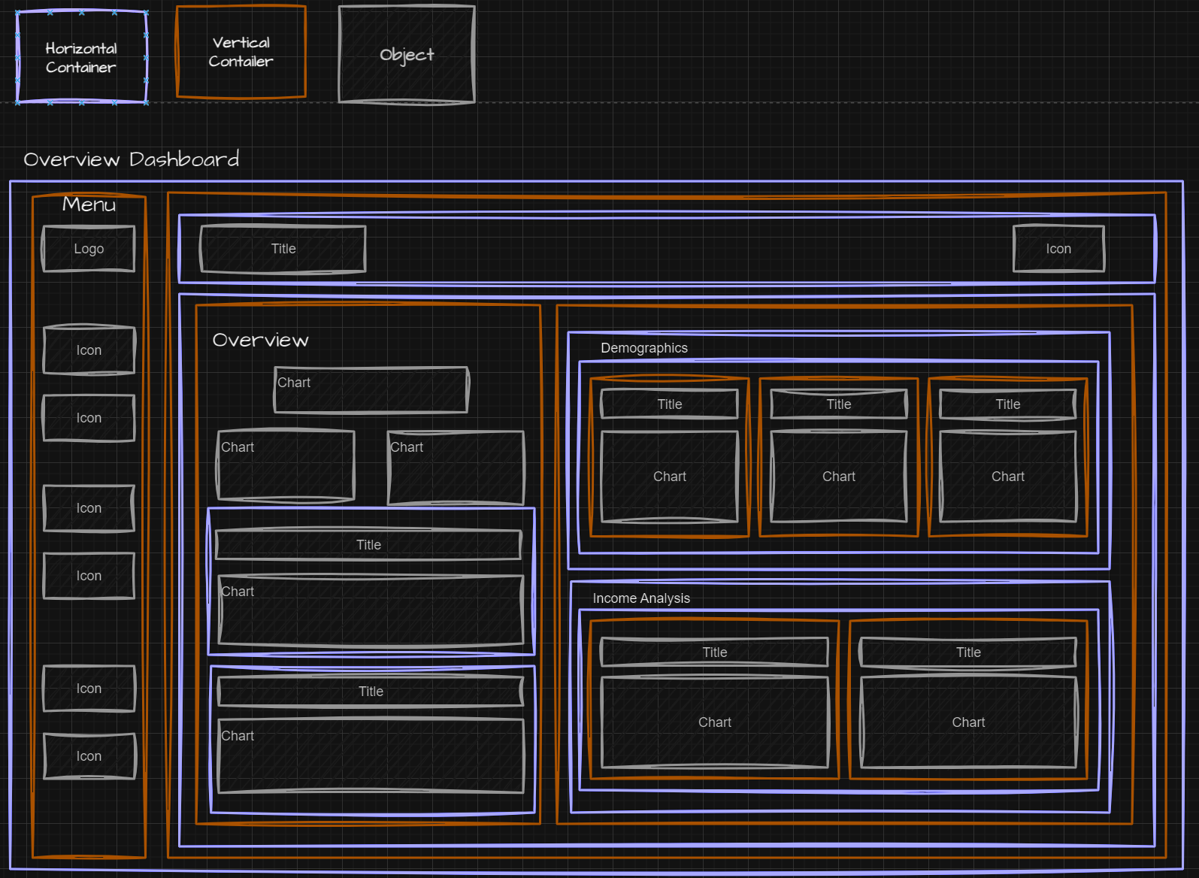

## Create Container structure

Now back to Tableau, I will re-create the container mock-up within tableau

1. First Create a new Dashboard and re name it to “HR | Summary” set the dashboard size to “Fixed Size” and 1400 x 800
2. Change objects to “Floating”, drag a “Horizontal Container”, select Layout change the size to same as the dashboard and give it a middle thick blue border
3. Rename the container by right clicking on it in the “Item hierarchy” pane
4. Change objects back to “Tiled”

## Put all Together

## Fixing Colours

## Fix Texts

## Fix Spacing

## Fix Tooltips

## Add Filters and Legends

## Add Logos and Icons

# Building Dashboard – Employee Records View

From the brief:

* Provide a comprehensive list of all employees with necessary information such as name, department, position, gender, age, education, and salary.
* Users should be able to filter the list based on any of the available columns.

1. Drag “Employee ID” to Rows, Format the worksheet to black and the text to Dark grey - #777777
2. In row type “AVG(-1.0)”, change the chart type to shape
3. Format all the line types of the worksheet to “None”, on the columns tab set “Grid Lines” to “None” and finally on the rows tab change the “Grid Lines” to a thin solid dark grey line
4. Hide the x-axis
5. Create a new calculated field called “Full Name”  
   [First Name] + ' ' + [Last Name]
6. Drag “Full Name” to Labels, drag “Gender” to Shape and colour, drag “Age” to label and finally drag “Education Level” to label
7. Select label and format as follows, align to the left.

“Full Name” on the first row emboldened and set to #f5f5f5 – Light Grey  
“Age" | “Education Level” set to Dark grey - #777777

1. Increase the size of one row until the label fits, remove both legends
2. CTRL drag the dimension in the columns in order to copy it
3. Format pane -> Grid menu -> Columns tab -> “Columns Divider: Pane” to “None  
   Format pane -> Grid menu -> Rows tab -> “Rows Divider: Pane” to “None
4. Select the 2nd of the two graphs within the Marks pane, remove all fields and drag both “Job Title” and “Departments to Label
5. Select label and format as follows, align to the left.   
   “Job Title” on the first row emboldened and set to #f5f5f5 – Light Grey  
   “Department” set to Dark grey - #777777
6. On size drag to smallest and on colour change opacity to 0
7. CTRL drag the dimension in the columns in order to copy it
8. Drag “Location” to colour, “City” to label, format and align to the left  
   “City” on the first row emboldened and set to #f5f5f5 – Light Grey  
   “State” set to Dark grey - #777777
9. Change the shape design to a filled circle, reduce the size to just under a ¼
10. CTRL drag the dimension in the columns in order to copy it
11. Drag “Salary” to Label   
    “Salary” on the first row emboldened and set to #f5f5f5 – Light Grey  
    On size drag to smallest and on colour change opacity to 0
12. CTRL drag the dimension in the columns in order to copy it